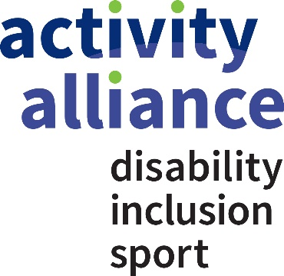

Active Partnerships: Activity Alliance’s support and resources.

Please find below further information about Activity Alliance support offer, improvement toolkits and resources.

Disabled people count for one in five of our population. Yet, disabled people are twice as likely to be inactive as non-disabled people. Activity Alliance brings members, partners and disabled people together to make active lives possible. Collectively, we continue to challenge perceptions and change the reality of disability, inclusion and sport. For more than 20 years, we have enabled organisations to support disabled individuals to be and stay active for life.

Our teams work at a regional and national level, and are at the centre of influential world-renowned programmes for disabled people. We share your ambition to make a difference to the people we work with and support. To do this, we provide a range of services to organisations in sport, leisure and physical activity sectors as well as give guidance information to this that support disabled people in their daily life.

Below summarises some of the support we can offer you, however if you want to find out more, please get in touch with our team by visiting www.activityalliance.org.uk/engagement for relevant contact details. Call us on 01509 227750 or email info@activityalliance.org.uk.

Strategic area | Resources
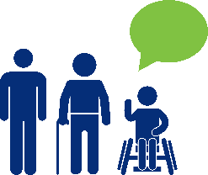  Engagement | We enable organisations to be more effective in reaching and engaging less active disabled people. Our range of resources, webinars, workshops and engagement days empower your teams to think and act inclusively at all levels of working:  Click here for Engagement Resources and click here for the accompanying learning presentations  Resources include:  - Effective Engagement  - Gathering & using insight on disabled people  - Engagement through research and insight  - Engaging older people  - Understanding children and young people  - Supporters role in engaging disabled people  - Talk to Me Ten Principles  - And much more.
Research and Insight | We aim to lead the way in knowledge and evidence-led insight on disabled people in sport and active recreation. Our research and insight explore barriers, motivations and lifestyles.  Click here for a full list of our research  Research includes:  - The Activity Trap Benefits or Being Fit  - Annual Disability and Activity Survey  - My Active Future: Including Every Child  - Delivering Activity To Disabled People The Workforce Perception Gap  - And much more
Inclusive programmes | We deliver a range of programmes and projects to support organisations to engage more disabled people. These include:  - Inclusive Activity Programme – training that equips community groups, volunteers and coaches with the skills to engage disabled people and people with long-term health conditions more effectively in activities.  - Get Out Get Active – Funded by Spirit of 2012, supports disabled and non-disabled people to enjoy being active together. Focused on getting some of the UK's least active people moving more through fun and inclusive activities.  - Inclusive PE training – free training workshops and resources for teachers, trainee teachers and school staff.
Inclusive marketing and communications | Inclusive and accessible marketing communications can help everyone to reach more people, including disabled people.  Our Inclusive marketing and communications guide and factsheets  support providers to be more accessible and inclusive in their communications.  Click here for guide and factsheets.
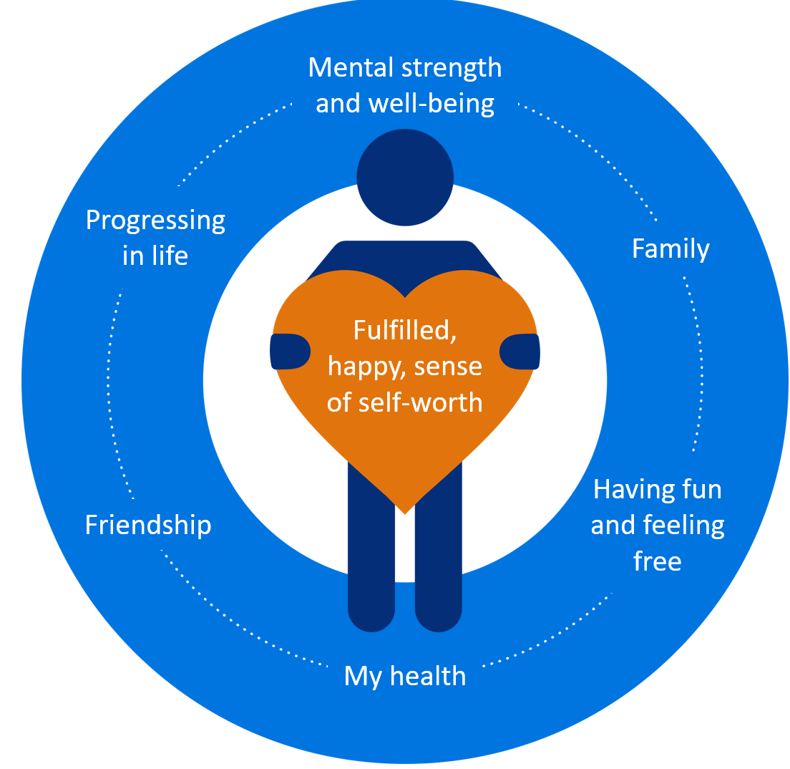  Other useful links/resources | Additional resources of note:  Talk to Me Ten Principles – Women  Get Out Get Active volunteering toolkit  Talk to Me Ten Principles – Older People  Women in Sport Get Out Get Active Toolkit - engaging women in activity  Being Active Easy Read Guide and Videos  Lead – Organisational Development and Improvement

